

Sadat Academy for Management Sciences

Graduation Project

SAMS-BOT

Chatbot for Sadat Academy for Management Sciences

**Presented by:**

Mazen Ibrahem   
Mohamed Hany

Mafdy Ashraf

**Supervised by:** Dr. Ghada Mostafa

**Table of content:**

Chapter One: Introduction 3

**Overview of the project** 3

**Problem Statement** 3

**Project Objectives** 4

**Technologies and tools used** 4

**Chapter Two: System Analysis** 5

**Requirements** 5

Gathering Techniques 5

Stakeholders 5

Functional Requirements: 6

Non-Functional Requirements 6

**Diagrams** 7

Context Diagram 7

Activity Diagram 8

Class Diagram 9

Sequence Diagram 10

ERD Diagram 11

Database Design 11

Entitles 13

Chapter Three: System Design 14

WebBot Configurations 14

User Interaction Scenarios 16

Coding Samples 21

Chapter Four: Conclusion 25

Conclusion 25

# Chapter One: Introduction

## **Overview of the project**

This project is a Chat-bot named “SAMS-BOT” that is specified for taking applicants (students and out-comers) inquiries and concerns for their concerns about the admission process.

Main stakeholders of this system are applicants who will use the system and college stuff who will be contacted by the Chat-bot to know the process of the admission phases.

In other words, the proposed software answers applicants and out-comers inquiry and notify each stakeholder about that inquiry.

The student affairs will have access to see Bots performance , add new answers and the chat will be protected.

## **Problem Statement**

* Every large university in need of customer service department pays a huge amount of money to customer service agents since they are needed 24/7 a week so they work in rotational shifts.
* In other hand, the university pays all these agents their salaries plus all the work station expenses nonstop since such a service cannot cease to exist.
* From the stuff point of view, is that the Bot helps in minimizing the time wasted on replying to repeated questions.
* From the applicants’ point of view, the Bot will allow them to find fast response for their regular questions.

## **Project Objectives**

“Building a Chat-bot in a year that answers all inquiries of the out-comers using questions with multiple choice answer using AI and other tools.”

* **Specific:** a chat-bot that answers all inquiries of out-comers using questions with multiple choice answer.
* **Measurable:** a success rate of the chat-bot can be measured by the number of inquiries handled error free.
* **Achievable:** Using AI and other tools.
* **Realistic:** some bots are already created so it’s possible and real to make one.
* **Time-bound:** will be finished in one year

## **Technologies and tools used**

* + Chatter-On.
  + Microsoft Excel.
  + Microsoft Access.
  + Microsoft Visio.
  + Adobe XD.
  + Enterprise Architect.

# **Chapter Two: System Analysis**

## **Requirements**

### Gathering Techniques

* We started by reviewing Chat-bot systems of other universities and companies and we found that most universities don’t have a chat-bot system.
* Those had chat-bot system it was serving as direct link for their website which was hard to find data in it and it was hard to find.
* Then we started talking and searching for information from inside our college boundaries as student affairs, students and professors. We found some FAQs that we addressed in the implementation of our chat-bot.
* We conducted some Interviews with the Student affairs Stuff to get and untraditional Questions that the Applicants could ask.
* That reviewing give us an overview about how Chat-bot mostly like and the Main keys that must be there.
* Then we started adding from our perspectives what might help end users in using our chat-bot to make it more Simple, reliable, friendly to use.
* Finally, we got feedbacks from a random users that have an early using experience of using “SAMS-BOT” to get their point of view after using and if they face any issues through the using experience.

### Stakeholders

**End users:** Applicants whom have inquiries about admission process.

**System managers:** IT Manager.

**Data provider:** Student affairs.

**System owners:** The Sadat Academy for Management Science itself.

### Functional Requirements:

* + - A User needs to be able to ask about any existing info that he need to know.
    - A User needs to be able to get a detailed info about Admission.
    - The bot can assign through website stuff that can answer non-structured questions.
    - The bot can be updated through the data coming from student affairs.
    - The bot gives the needed information to the out comer with no need to go to any branch to ask for any inquiry.
    - The bot checks the validation of the information with patch update created every year.

### Non-Functional Requirements

* Usability
* Acceptability: people can accept dealing with such a new system (Bot)
* Socially acceptable
* Effectiveness
* Ethics
* Security
* Easy to use
* Efficiency
* Functionality
* Reliability
* Maintainability

## **Diagrams**

### Context Diagram

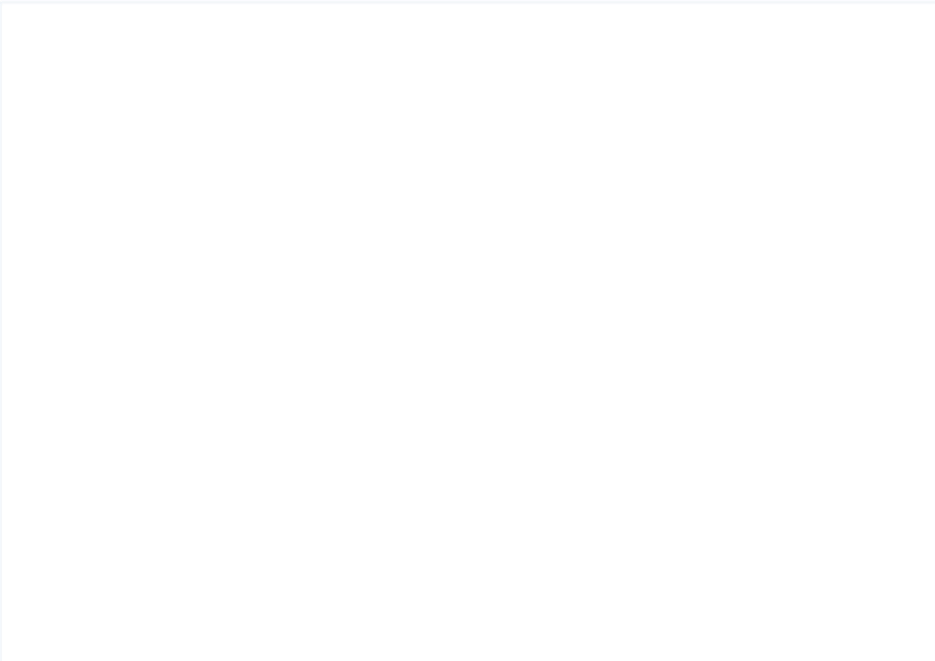

**Admission**

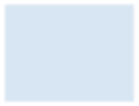

Student affairs

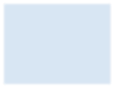

Applicants

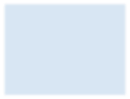

Questions

Give information, create, delete, edit

Give Answer

New applicant applies and ask question

View

Categorizing question

Receive answer

*Figure 1: Context Diagram*

### Activity Diagram

Ask a question?

answer exists

No

Request human

interaction

Yes

Send answer back

Satisfied with answer

No

Yes

*Figure 2: Activity Diagram*

### Class Diagram

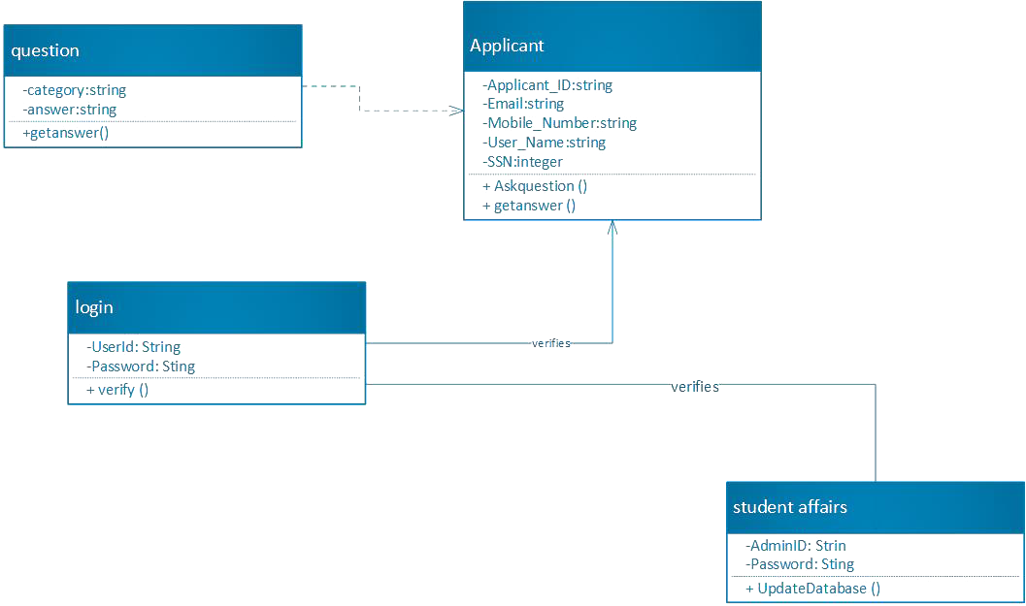

*Figure 3: Class Diagram*

### Sequence Diagram

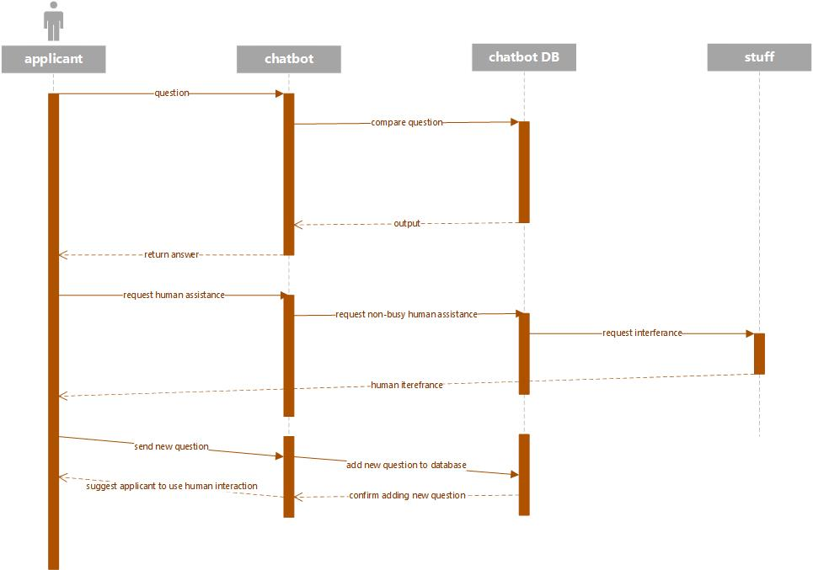

*Figure 4: Sequence Diagram*

### ERD Diagram

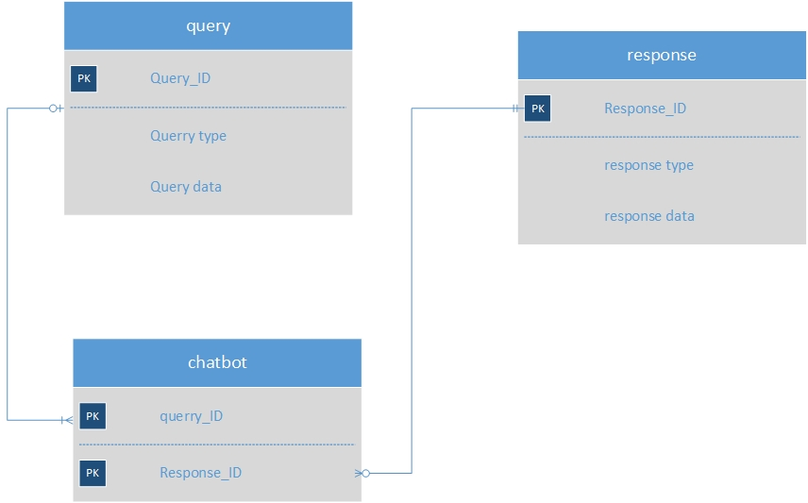

### Database Design

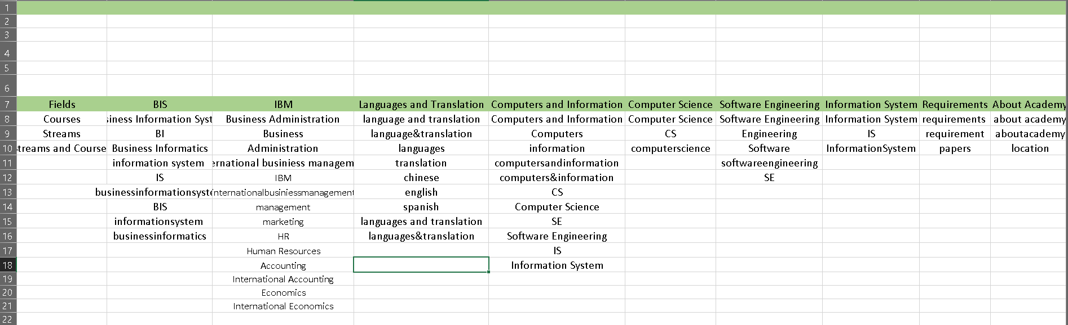

### Entitles

# Chapter Three: System Design

WebBot Configurations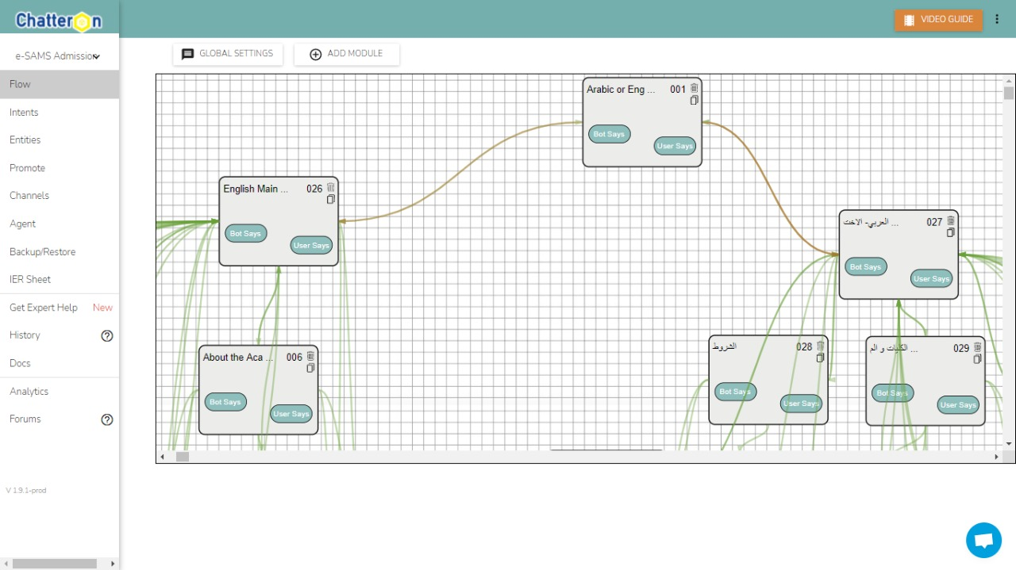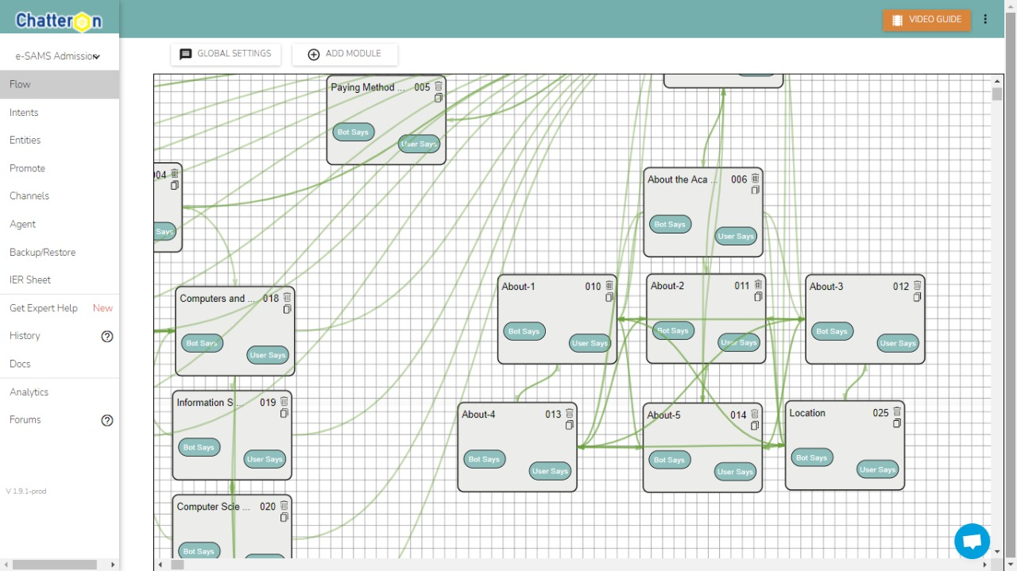

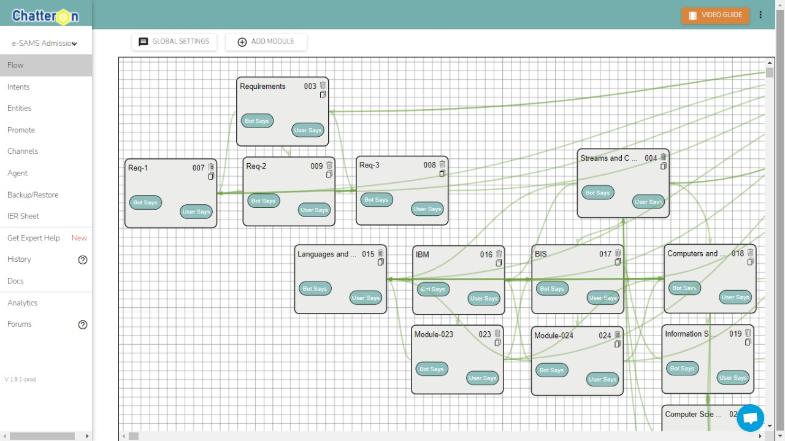

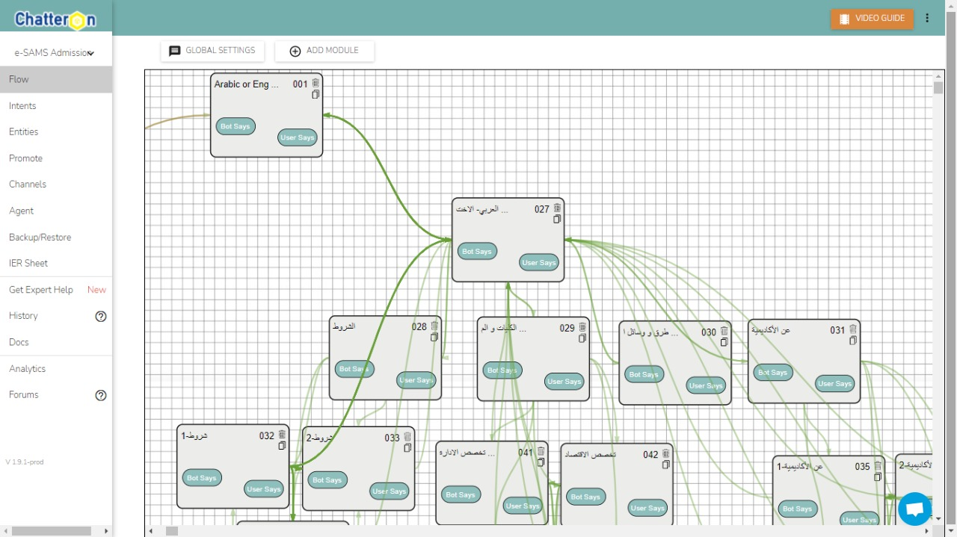

## User Interaction Scenarios

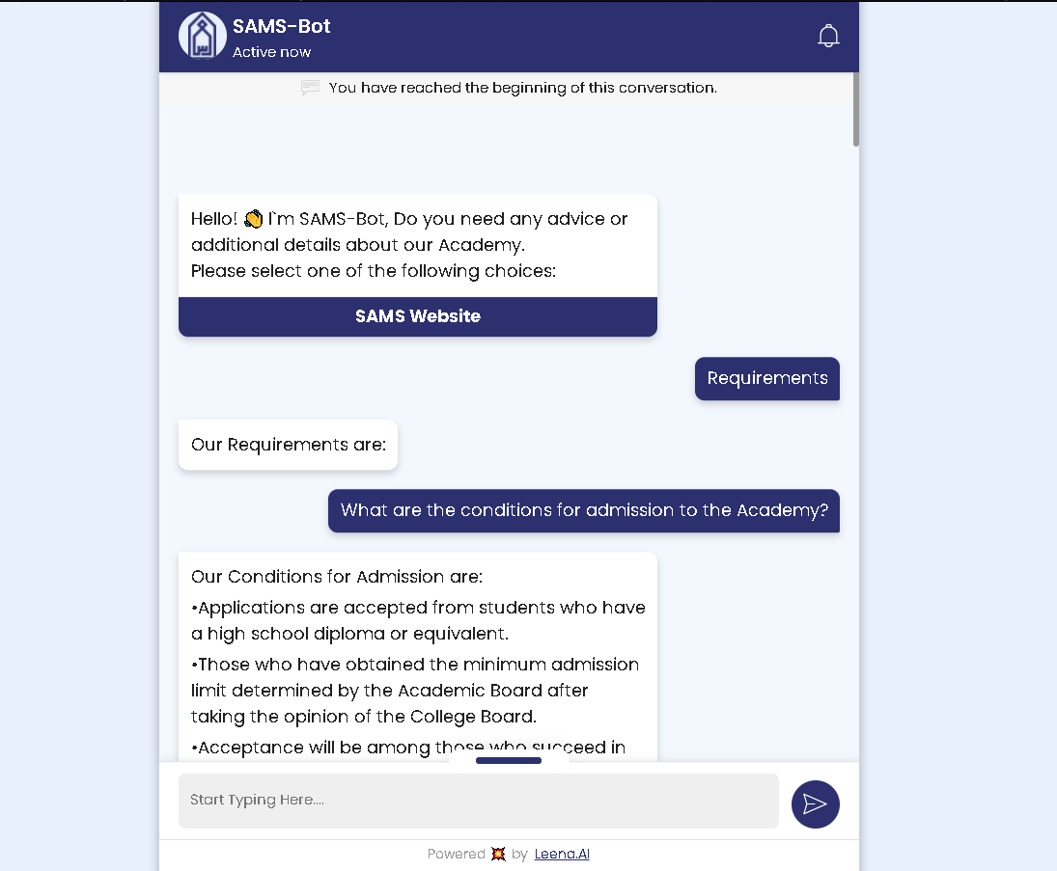

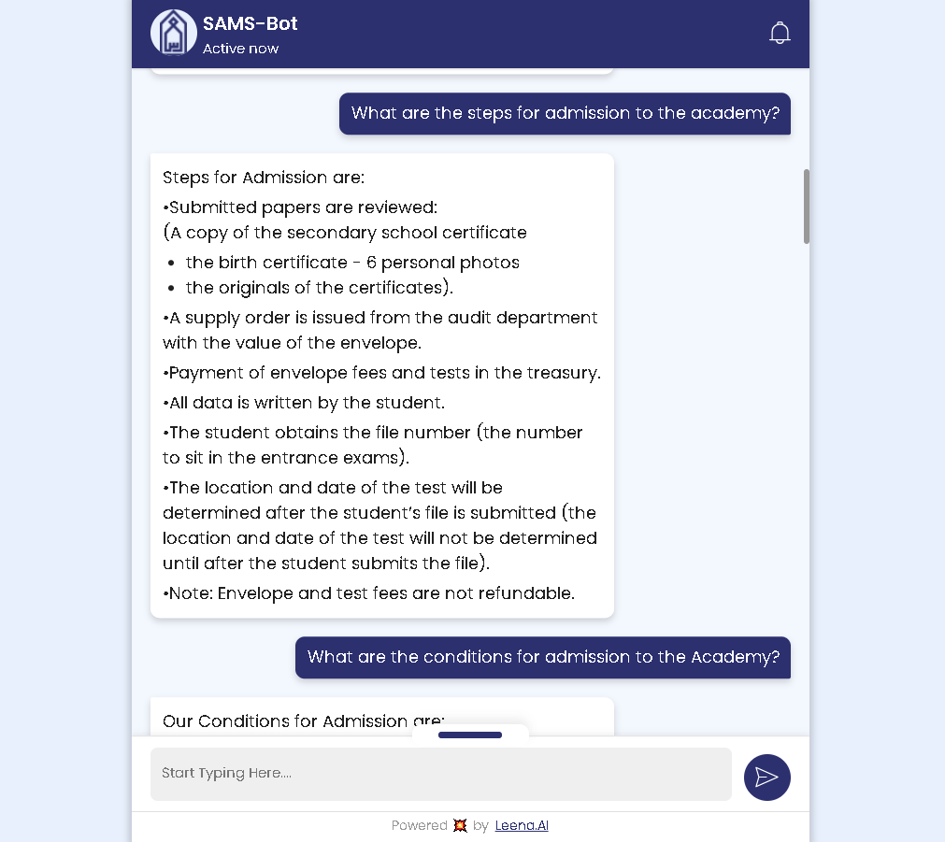

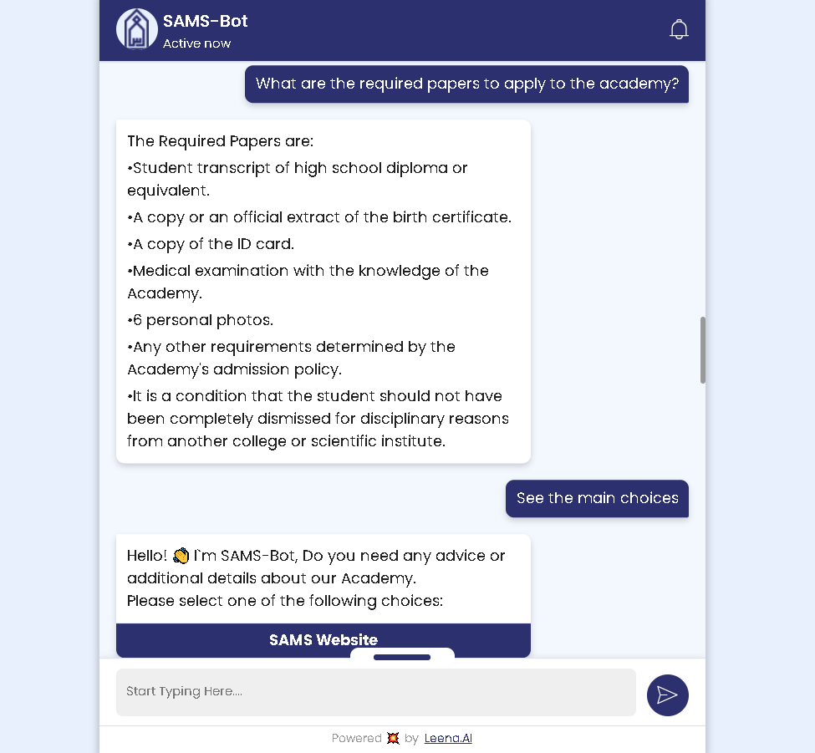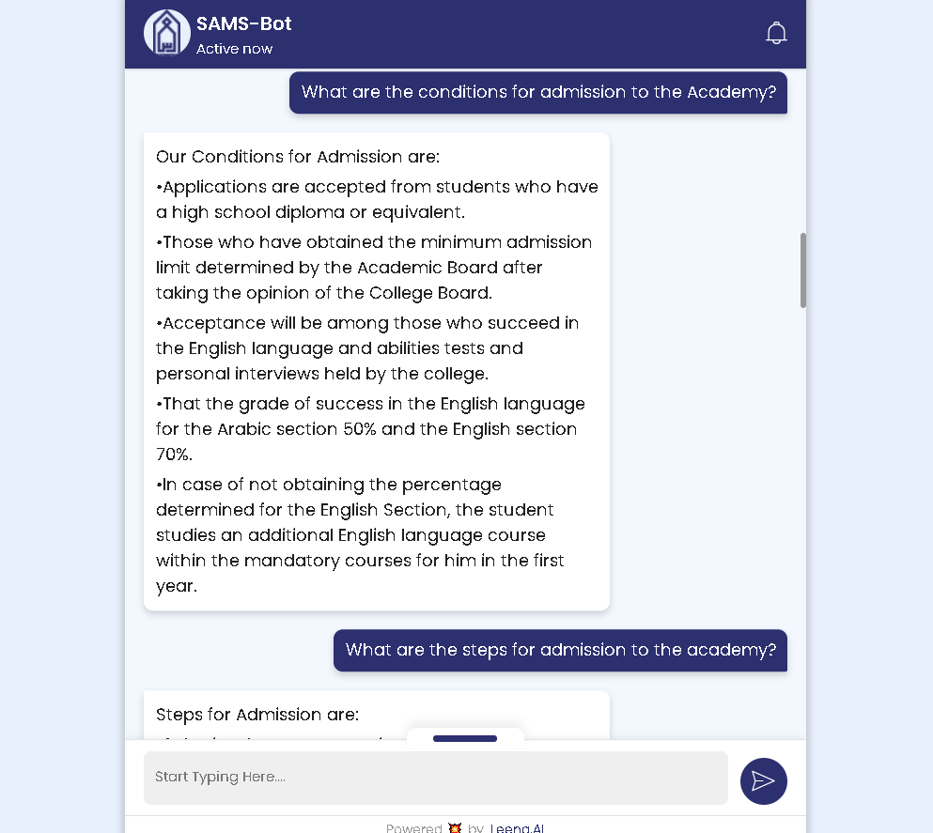

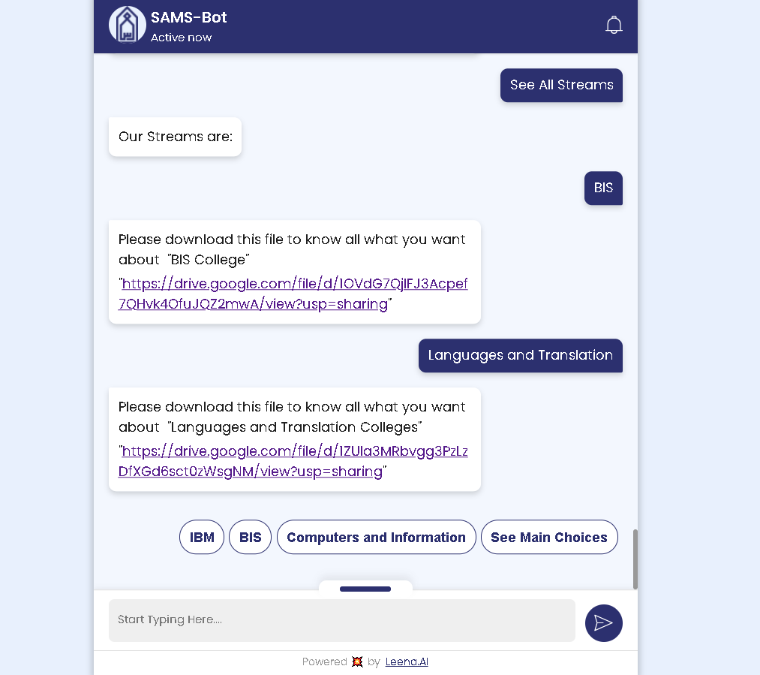

## Coding Implementation

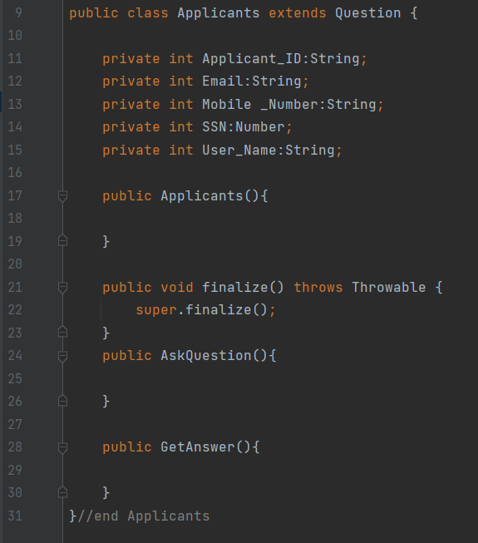

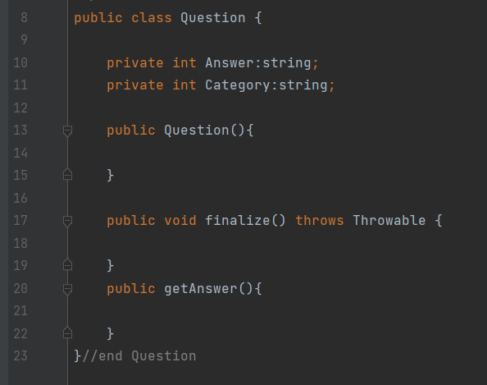

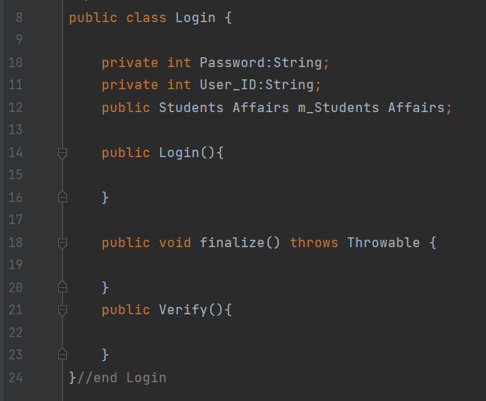

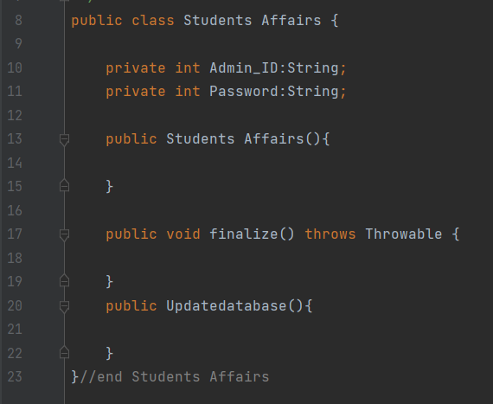

### CSS:

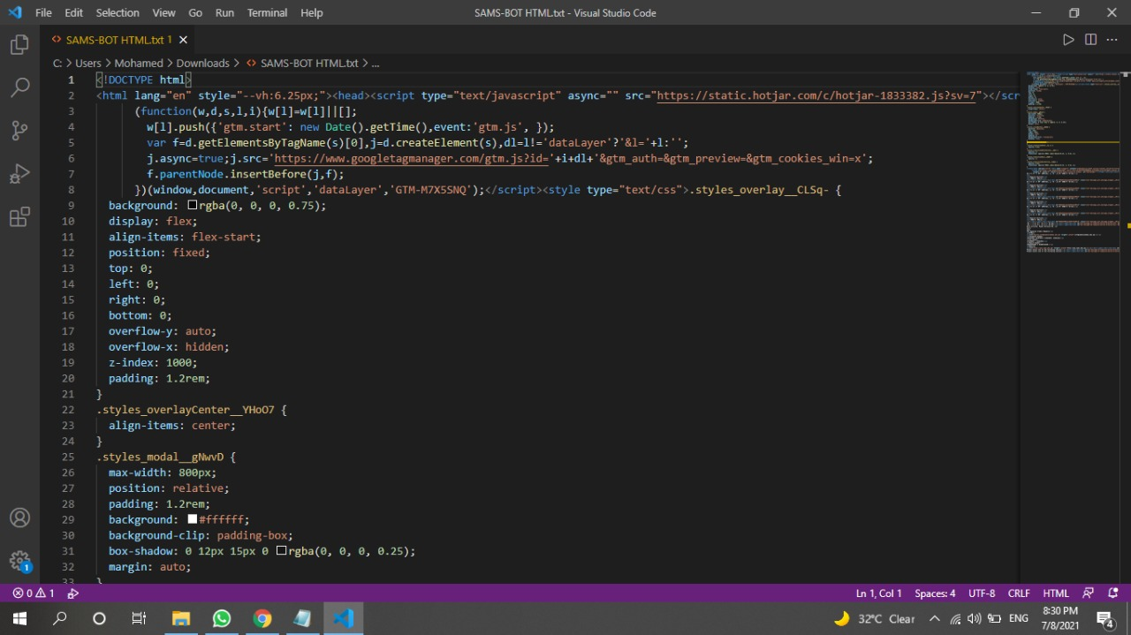

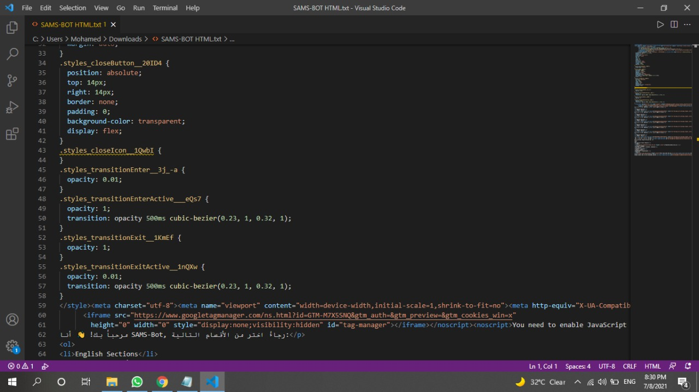

### Answering Query:

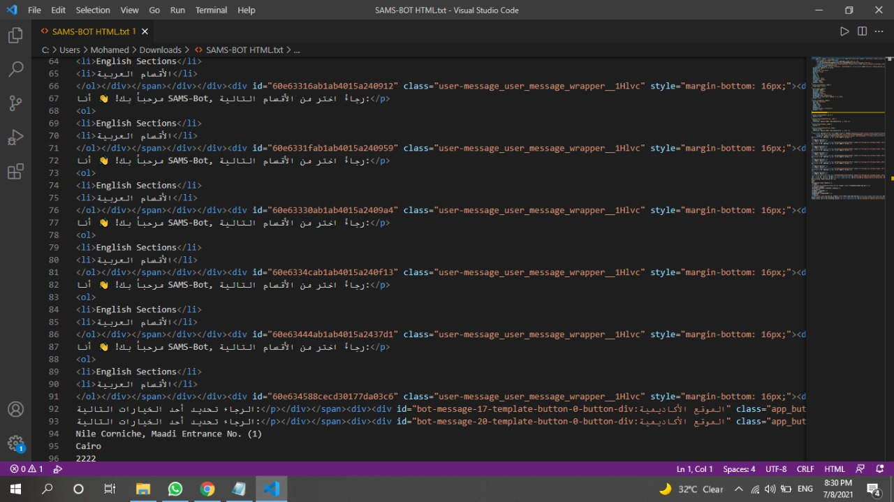

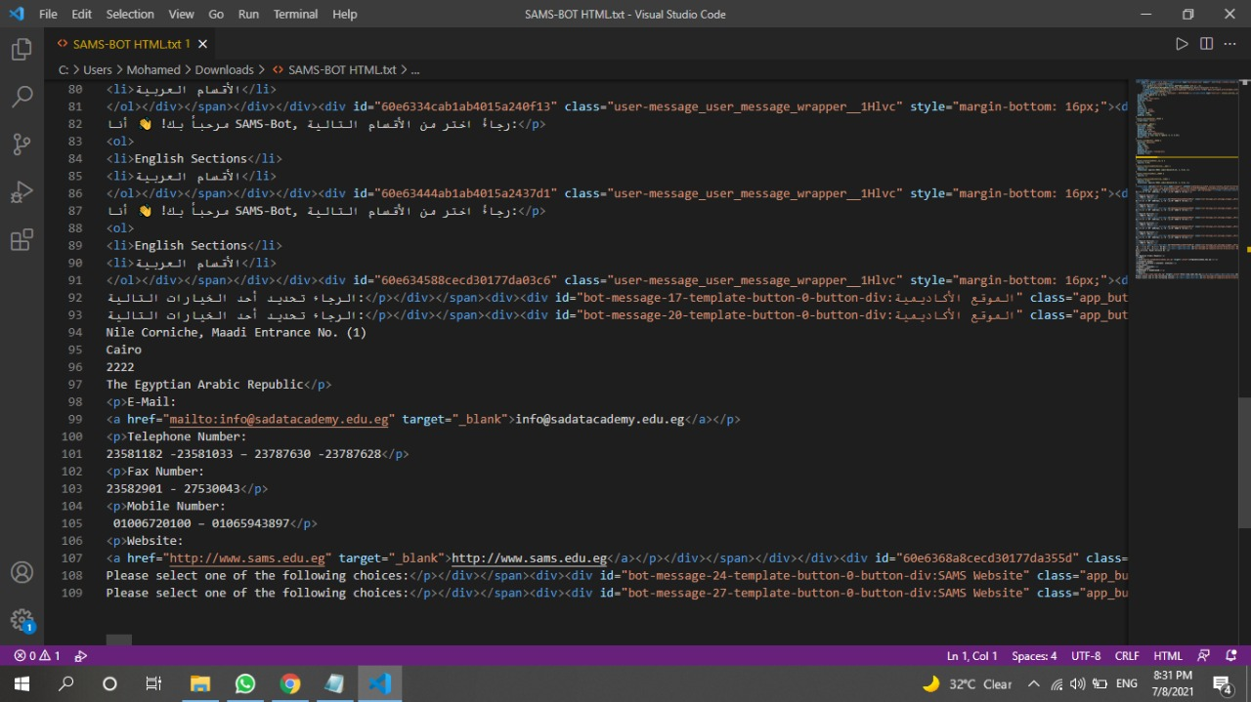

# Chapter Four: Conclusion

## Conclusion

We believe that one of the ways to be a professional and have the worldwide standards that the Academy must have the tools that effect the image of the Academy and also help to get the Process more efficient and quicker , and the Idea of the Chat-bot has a worldwide request as it make it easier to get a quick response for any inquiry that the user could have and It lower the cost of the Customer service department that would cost the entity huge amount of money that could got invested at any other required department .

We expect that this project will make a huge difference in customer service field. And also have a great turnover and great benefits to SADAT ACADEMY that have a little Issues with customer service.